Distribution Formulas of Pennsylvania Public Library Systems
Association of Pennsylvania Public Library Systems
Updated August, 2008

Responding Library Systems

- Adams County Library System
- Allegheny County Library Association
- Beaver County Library System
- Bedford County Federated Library System
- Berks County Public Libraries
- Blair County Library System
- Bradford County Library System
- Bucks County Free Library
- Butler County Federated Library System
- Cambria County Library System
- Chester County Library System
- Centre County Federation of Public Libraries
- Crawford County Federated Library System
- Cumberland County Library System
- Delaware County Library System
- Franklin County Library System
- Greene County Library System
- Jefferson County Library System
- Lackawanna County Library System
- Lawrence County Federated Library System
- Lebanon County Library System
- Library System of Lancaster County
- Lycoming County Library System
- Luzerne County Library System
- Potter-Tioga County Library System
- Schuylkill County Library System
- Somerset County Federated Library System
- Washington County Library System
- Wayne Library Authority
- Westmoreland County Federated Library System
- York County Library System
ADAMS COUNTY LIBRARY SYSTEM

The Adams County Distribution formula for County and State funds is very simple. Our one federated member receives 9.33% of the total. This is the population of their service area.

I am not really sure there is a measurable objective for this formula other than parity
ALLEGHENY COUNTY LIBRARY ASSOCIATION

1. Your system's funding formulas and what those formulas are intended to achieve:

We currently distribute funds to libraries under 4 scenarios:
- Access PA (according to the State’s factors)
- Regional Use Reimbursement (which is Regional Asset District money that rewards non-resident use similarly to Access PA) – this is a quarterly pay-our based on actual usage statistics.
- State Aid (we have historically allocated these funds in a formula that directly incorporated the State’s factors for independent libraries – the Member Library agreements specify that libraries will receive what they would if they were independent of the system – so no extra dispensation for being system members. However, since the state aid formula itself is basically defunct, we have merely been adding % increases as the state mandates – which we are EXTREMELY unhappy about, because there are therefore no consequences and/or rewards for changes in library performance since 2002-03).
- RAD funding is distributed based on a number of factors including service district population, distress, equivalent local mils of support, other local support, hours of operation, turnover rate. I am attaching a copy of the 2008 RAD distribution formula. You will note it is capped at the amount of funding available (which is less than the actual formula factors would require).

2. Formula changing?

Yes, we are in the middle of a lengthy review of our distribution formula (primarily the RAD formula). The Members had indicated they wished to revise the current formula to include some performance factors pegged to the strategic initiatives of the organization. A formula was developed and approved by 2/3 of the Members in May of 2006. However, it combined State Aid and RAD funding into a single formula. The State mandate regarding distributing the same amount of funding as in the previous year threw everything up in the air and we were forced to abandon that formula. Since then we have hired outside consultants to develop a new formula and we anticipate this process will take place over the next 18 months with a new formula at the end of that time. The formula has been an issue since the inception of ACLA – small and/or distressed libraries feel the formula unfairly rewards large/wealthy libraries, the large/wealthy libraries feel they are not getting enough return on their local investment…If we come up with the magic solution that makes everyone happy, we’ll let you know!

3. How the system itself is funded and administered.

We receive administrative support from the Regional Asset District. That comprises most of our administrative budget. In addition we charge administrative fees to the programs that we operate for direct service (Mobile Services, Knowledge Connections, Robinson Township Library). We retain a portion of state aid for system services to member libraries – this is funding that exceeds what each library would qualify for independently of the system, funding that is earned by the system in part for the local financial effort represented by the monies spent on our own operations. We do not receive the County Coordination Aid – that goes to the Carnegie Library of Pittsburgh.

4. Is your system headquarters a library or an administrative office only?

We are an administrative office only. We do provide some direct service to the public (see question 3 above) – but we do not operate in conjunction with a library.

5. Does your system have its own staff or shared staff?

Yes, our system has its own staff – including outreach service personnel (operating those direct services above) and system service personnel (for the work our headquarters does in terms of advocacy, consulting, continuing education, grant programs, etc.). The former represents (in 2008) approximately 13.8 FTE’s and the latter represents approximately 6.4 FTE’s.
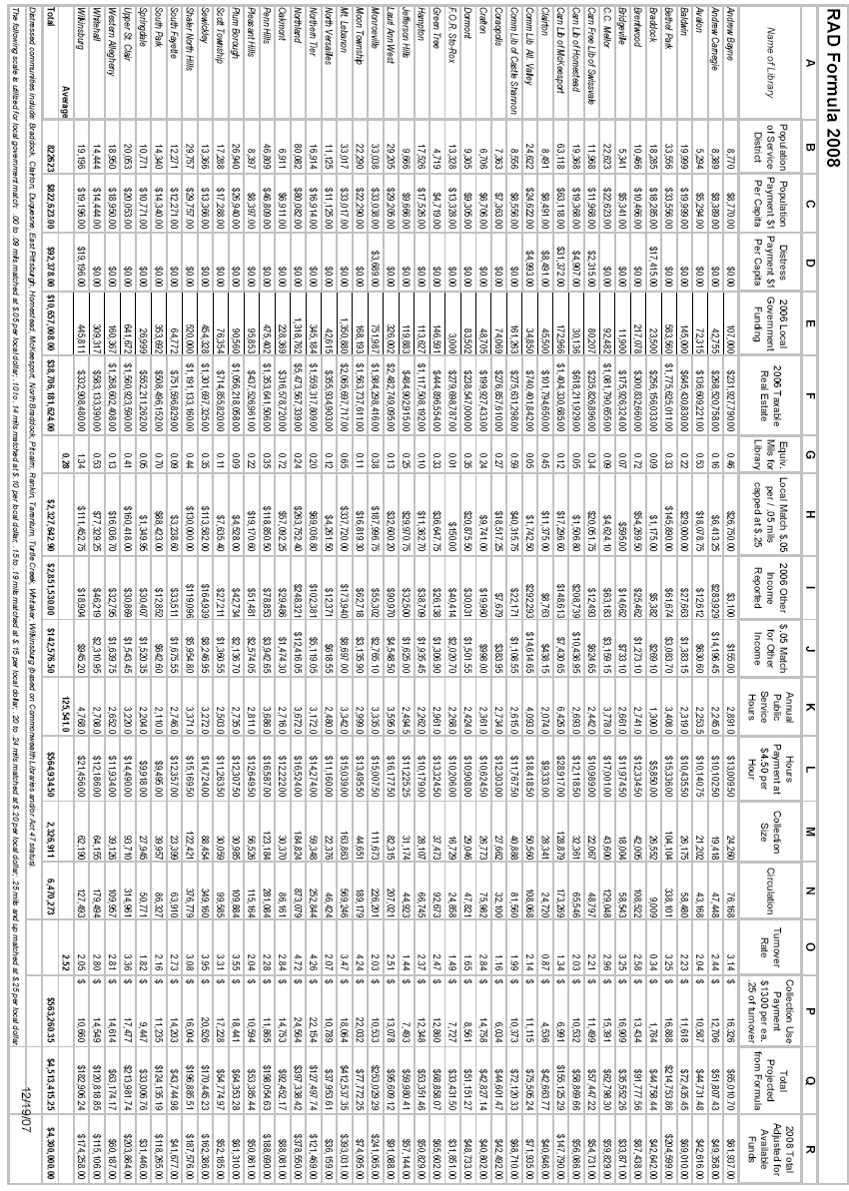
BEAVER COUNTY LIBRARY SYSTEM

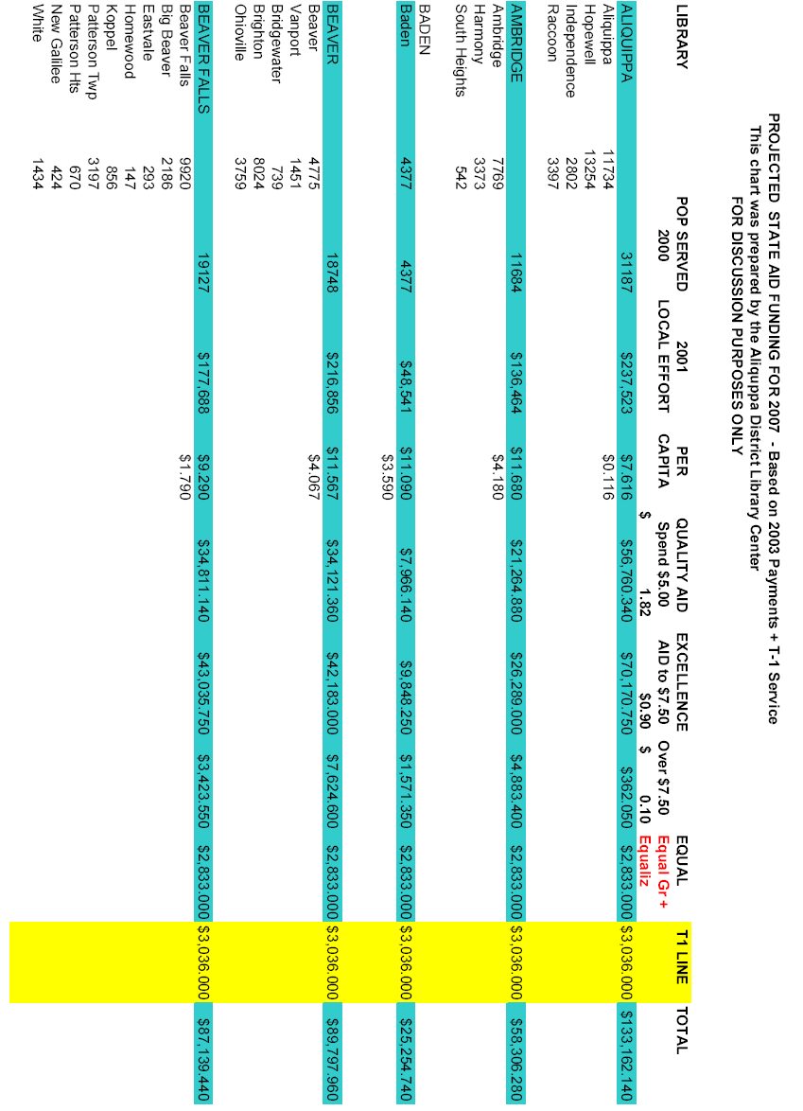

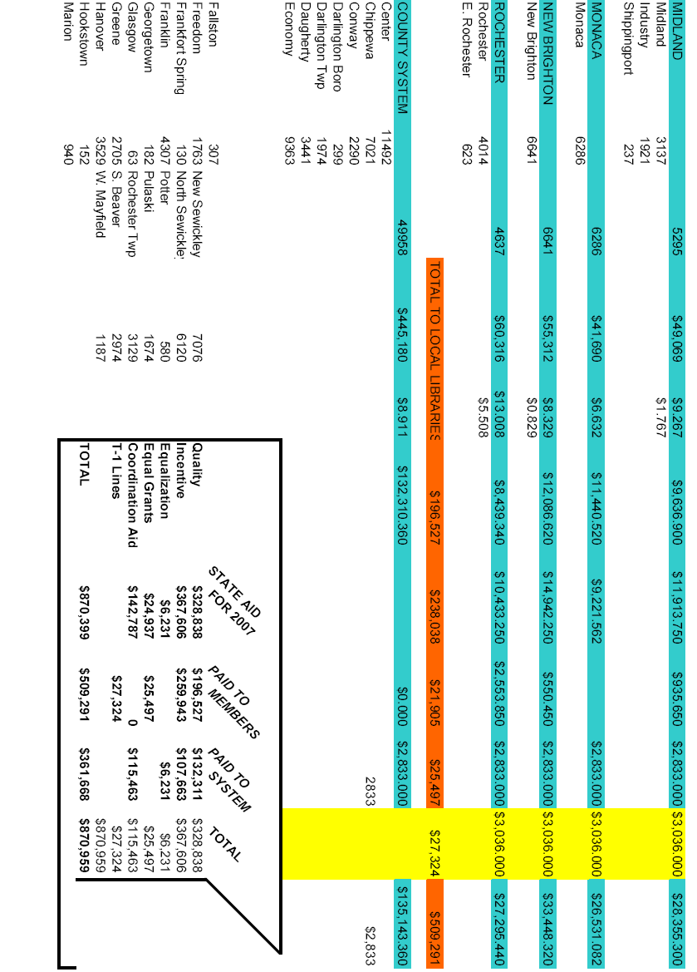
BEDFORD COUNTY FEDERATED LIBRARY SYSTEM

All of the State Aid and County Commissioners appropriation/contribution is deposited in the System account.
Money is taken off the top (specifically, from County Coordination Aid) for the operating budget of the bookmobile and for a bookmobile replacement fund (specifically from the County Commissioners appropriation/contribution). The remaining money is then distributed to the member libraries via a population formula.

BEDFORD COUNTY LIBRARY SYSTEM 2008

prepared: December 6, 2007

State Aid 2008 = 291,659
minus County Coordination Aid = 071,092
TOTAL state aid available for distribution = 220,567

County appropriation 2008 = 133,817
minus bookmobile set-aside = 010,000
TOTAL county aid available for distribution = 123,817

TOTAL System funds available
for per capita distribution = 344,384

BEDFORD COUNTY LIBRARY (58.8568%) = $202,693
state = $129,818
county = $72,875

EVERETT FREE LIBRARY (26.6585%) = $91,808
state = $58,800
county = $33,008

SAXTON COMMUNITY LIBRARY (8.9529%) = $30,832
state = $19,747
county = $11,085

HYNDMAN PUBLIC LIBRARY (5.5318%) = $19,051
state = $12,202 county = $6,849
BERKS COUNTY PUBLIC LIBRARIES

Here is a brief description of our funding formula. If I had to summarize its purpose, I guess it would be to keep our libraries afloat! Although we are better funded than some, we still have a county full of subsistence-level budgets.
System HQ is an administrative unit, however we do have an assigned service area that is served by our bookmobile. We do not use any state aid to fund that program. System HQ staff is 22.5 FTE. Let me know if you want info about what they all do; I will send you our System Manual.
My board has been examining the possibility of adding a computer use component to the funding formula. Still to be determined are: 1) the definition of "computer use"; 2) how to account for the disparity in the number of computers available in each library; 3) how we will implement the "counting" of computer use; and 4) what % of the funding will be distributed based on computer use. We have purchased computer management software for the libraries (Cafezee) so they can try it out and so we can look at the data it gathers. I expect that our 2009 formula will have this new component.

STATE/COUNTY AID DISTRIBUTION

Funds distributed include 100% of the State Aid received by the System in the categories of Quality Libraries Aid, Incentives for Excellence Aid, and Equal Distribution Grants. [These are the state’s designations for the components of the Aid to Public Libraries appropriation.] Also distributed is the amount in the County Aid line of the System’s budget; the Commissioners make the ultimate decision about the amount of money that goes into this line item.

The State and County monies are combined into one fund which is distributed in quarterly payments to the libraries based on the following formula:
1) Municipal Incentive Funds are distributed to libraries on a per capita basis according to the population of their service area municipalities that contribute at least $1.00 per capita in monetary support to the library. This $1.00 of municipal support is matched by $1.00 of System funds. This category of funding is designed as an incentive for higher levels of municipal support. Currently, there are 38 municipalities that contribute less than $1 per capita.
2) Base Allocation: One half of the remaining available funding is divided into 23 equal shares, one share for each member library and the RPL branches.
3) Variable Allocation: The remaining funds are distributed as follows: 35% based on share of local financial effort; 65% based on share of circulation.

Libraries are penalized for failure to meet the eight Envisioning Excellence Guidelines; $1,500 is deducted from the payment total for each Guideline not met. If the same Guideline element is not achieved for a second consecutive year, the penalty is doubled.

BLAIR COUNTY LIBRARY SYSTEM

Attached are the System's two formulas. The State formula is based on 25% equal distribution to all eight libraries, 65% is based on Local Financial Effort, and 10% is based on Population.

The County formula is based on Altoona receives about 50% of the county budget. The other seven libraries receive a "base amount" and then another portion based on population.

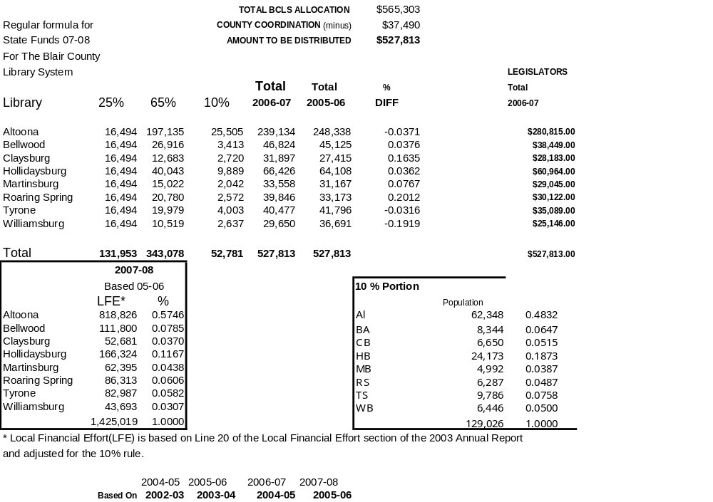

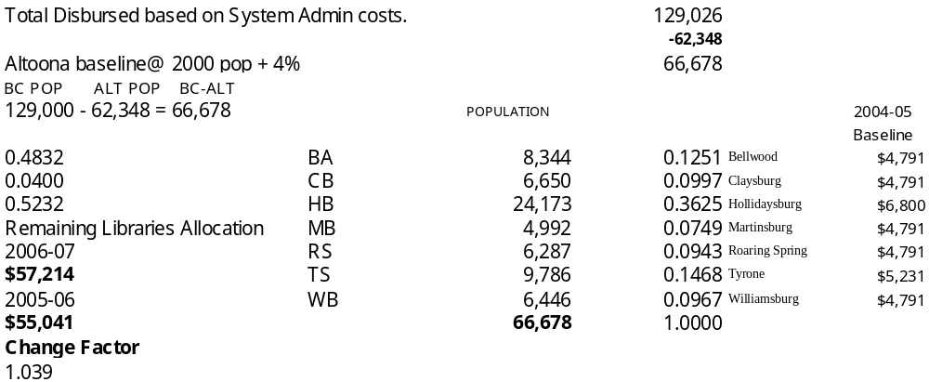

BRADFORD COUNTY LIBRARY SYSTEM

Bradford County Library System distributes its state aid using the following factors:

Population
Local Financial Effort
Equal Grant
Economic Distress (on the same conditions as the state, ie if the state gives it to an area, we pass the money along)
%Capita LGI

We do not take any money off the top to finance expenses for running the system. That is paid for with $15,000 included in county coordination aid (as all state aided county libraries are in our system) and a contribution from Bradford County government estimated to be 35% to 50% of our total budget.

It becomes 50% if the cost of the bookmobile is taken into consideration as a system service.
BUCKS COUNTY PUBLIC LIBRARY

I am messaging because Bucks County has a unique and mutant situation. What we are doing is NOT a “best practice.” I do not want to be unresponsive—in terms of participation. At the same time I do not believe it would have value to other libraries to follow our model. I hope to give you a small amount of information about our situation. I am asking your opinion regarding—what can I say on the APPLS website that would be responsive yet not be TMI for everyone given that we do not want to recommend our model.

- We have a total of 8 state aided libraries that are eligible to join our system. While most library systems require that you MUST join the system to receive the system benefits (i.e. fill out the paperwork, sign the contract, etc.) this was never required in Bucks. So 5 joined our system and 3 did not. Yet we extend and have always extended the exact same benefits to everyone—those that joined and those that did not.

- The County does NOT implement a funding formula where we distribute cash to anyone. The benefit of system membership is and always has been—free centralized Technical Services (book ordering, cataloging, linking, delivery); free (or extremely well subsidized) IT services (catalog, network, PC support, help desk). County Coordination funds are spent to a large extent on centralized services for everyone. We have seven branch libraries supported by County funds— County plus County Coordination funds “pay for it all” for everyone.

- The original goals/objectives of doing things this way are a mystery to me. If anything I believe that the individual libraries benefit from a high level of centralized services in both IT and Technical Services that might not otherwise be possible for them.

BUTLER COUNTY FEDERATED LIBRARY SYSTEM

ARTICLE XII – Disbursement Formula

1. It is understood that all of the funds of the Affiliated Libraries would be passed through the
Federation and that the first tier of the system was to see that all of the Affiliated Libraries receive their individual funds as soon as it is physically possible. This is merely a conduit through which Independent Affiliated Libraries’ funds from the State are passed.

2. The Second tier of the Affiliated Library System dealt with the cost of administration. The
Headquarters Library costs and any costs in development of the Federation should be paid from the contributions made by the County and by the State to the Federation.

3. The third tier of the disbursement system of the Federation involved the funds that were left
over after the payment of the administration costs. Of that amount, a sum equal to X percent of the total amount to be distributed should be set aside to be distributed equally among the
Affiliated Libraries. The remaining Y percent of the amount would be distributed to the Affiliated Libraries on a “pro rata” basis using local effort as the criteria for determining pro rata shares. The values of X and Y are to be determined annually; however, the value of Y must be greater than X at all times. For the purposes of this distribution, local effort is defined as the operating expenditures of the Affiliated Library except for State, County, and Federal Funds. Third Tier monies will be distributed to member libraries within 30 days of their receipt by the BCFLS Administrator.

Since the inception, our practice has evolved so that approximately 60% of the County’s contribution is distributed to the member libraries. The actual amount is set each year by the BCFLS Board’s adopted budget. Part of that 60 % is “Third Tier” and part of it is administrative costs given to one library to serve as the resource library for the system. Our system administration is separate from that resource library. Of the Third Tier money, usually 40% is distributed equally and the other 60% is distributed based on the most recently completed state report’s local financial effort minus the third tier and resource library money for that year. The idea is to strongly encourage the member libraries to maintain or increase their own locally raised funds – local municipalities and library-related funds. The larger their share of the total local effort, the larger their share of the third tier for any given year.

CAMBRIA COUNTY LIBRARY SYSTEM

State and County Funding Distribution

State aid closely follows the state’s formula for distributing quality aid, equalization aid, incentive aid and the equal grant.

The county formula has not been revised in some time. I would like to revise it but until we would see a substantial increase in county funds, I don’t think it would fly—the winners and losers argument. Currently, we receive a mill from the county but not by referendum.

Because we are also a district center, I am both the district administrator and the system administrator. I do have a County Coordinator, paid with county coordination aid, who works solely for the system. I consider her to be the assistant system administrator which is needed because I do wear both hats. A bookmobile driver and part-time clerk also work for the system. No other staff work just for the system.

Lynn Meek

State Aid Formula

Quality Library Services Aid:

Current Population X Rate of $1.82

Equalization Aid:

Population X Rate of 0.28547891 + Flat Rate of $1,354.47

Equal Grant

Incentive Aid:

% of System local effort X System total local effort

County Funding Formula

The county library (headquarters library) receives 70% of the total county appropriation. One of the thirteen other member libraries receives 10.35% of the remaining 30% and the rest is equally divided among the other twelve libraries.

The library receiving the 10.35% share has a larger assigned service area and meets higher standards.
CHESTER COUNTY LIBRARY SYSTEM

Chester County Library is the District Center and also the Chester County Library System headquarters. We are also the Chester County Library—the County library with one branch (Henrietta Hankin Branch) that opened in 2003. CCLS staff and CCL staff are one and the same. The Executive Director of the CCLS is the County Librarian; the CCL director (vacant) manages CCL and Hankin, and works closely with the CCLS Executive Director and the District Consultant (vacant) Librarian to plan, coordinate and communicate to the 17 member libraries, 2 of which are branches—one is our branch, and one is the branch of the Tredyffrin Library (Paoli). Basically, our County budget is based on a millage and covers personnel and facilities costs at CCL and Hankin, as well as part of our connectivity costs. The state funding we receive—Quality, Incentive, District Center, County Coordination and Equal Grant aid categories—covers material, programs and whatever else. We also raise revenue by fines, fees and donations. We have a Friends of the Chester County Library (CCL only) which is a separate 501 (c ) 3 organization. We also have a Chester County Library Trust (also a 501 (c ) 3) that we are currently working with to raise an endowment. There is also a Fund for the Chester County Libraries, to benefit CCLS, and is administered by the Chester County Community Foundation.

We work with 2 funding formulas: to distribute our state aid (Quality, Incentive and Equal Grant categories) to each library in the system, including us. The District Center and County Coordination Aid stays with CCL, but is expended on behalf of the District and CCLS. Chester County also provides funding to the member libraries to assist them in providing materials and services to all residents of Chester County. That funding is distributed via our county funding formula (not including CCL and Hankin, since we are funded by County funds anyway).

The county funding formula to member libraries has 4 sections:

a per capita distribution based on the library’s service area as a percentage of the total population of member libraries’ service areas (minus CCL and Hankin) incentive aid distribution based on the library’s local income and municipal funding for the preceding year; the distribution is taken as a % of the member libraries’ total LFE (minus CCL and Hankin) equalization aid distribution based on the library’s service area % of (inverse) market value (minus CCL and Hankin); and output aid distribution based on the library’s % of total circulation (minus CCL and Hankin)
I will attach the spreadsheet for 2008. It actually has two additional sections at the end because of some separate funds that were previously allocated and an extra $100K for 2008. The basic formula, though is contained in the first 4 sections. This formula was developed by the CCLS in 1998.

The state funding formula that distributes the Quality, Incentive and Equal Grant categories of aid also has 4 sections (understanding that we could not run this again this year, since the state could not run theirs!):

A $1/capita municipal match incentive distribution based on 2000 population; if a library received a minimum of $1/capita from a municipality, we awarded them $1 from state aid; incentive aid distribution based on the libraries’ other income as a %; equalization aid distribution based on % of (inverse) market value; output aid distribution based on % of total circulation of previous year; equal distribution grant: set by Commonwealth Libraries.
The spreadsheet I’m attaching shows how it would work IF we could run it. This was a projection we made in the fall. The state aid formula was developed by CCLS in 1999 in response to the significant increase in state aid that year.
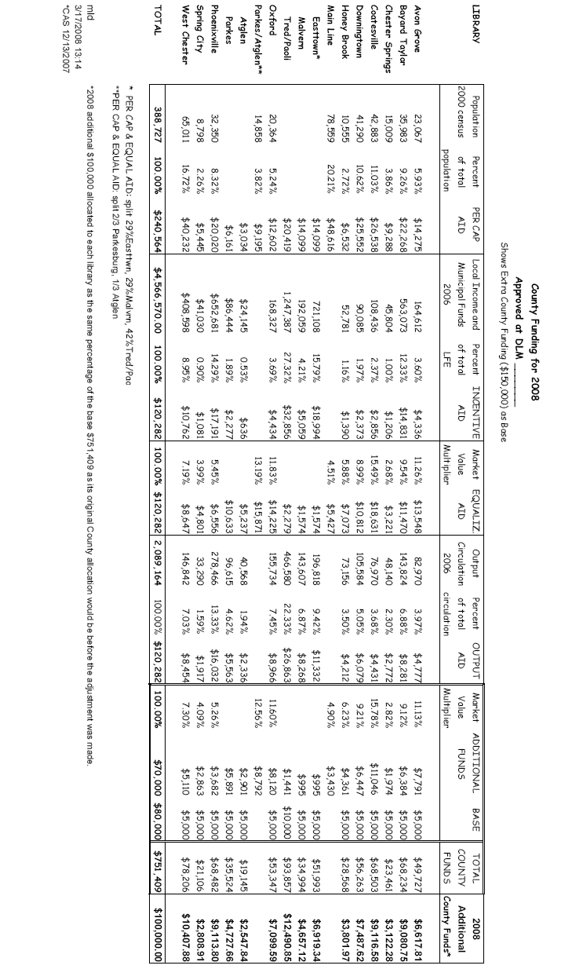
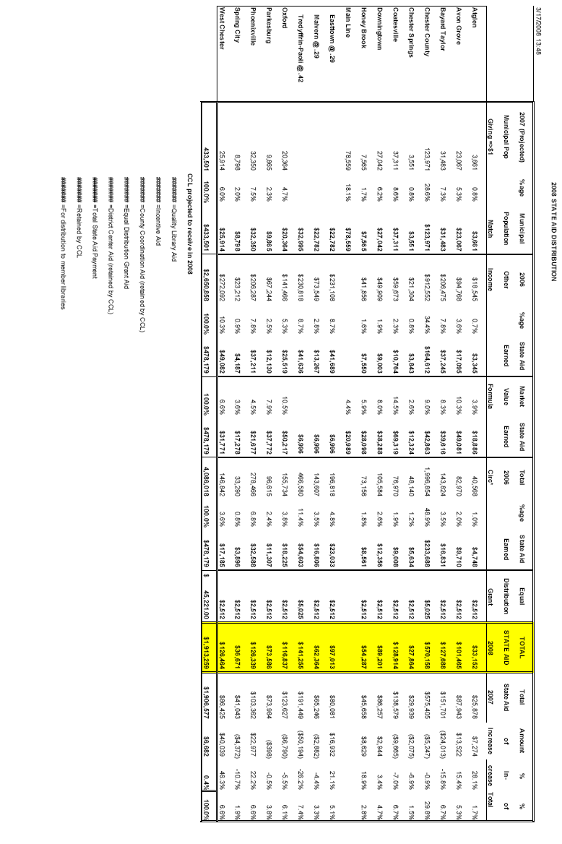

CENTRE COUNTY FEDERATION OF PUBLIC LIBRARIES
The Centre County Federation of Public Libraries has only two member libraries - Schlow Library and Centre County Library. Centre County Library has three branches and a bookmobile as well as their main library in Bellefonte.
The federation was formed in 1990 and the funding formula kicked in the following year. 1990 was considered our base year. Whatever each library received at that time remained their funds forever. Any funds to the federation beyond what was received in 1990 were distributed according to the following formula --
1/2 of the increase was divided in half. The other 1/2 was divided according to relative circulation. Equal grants, Access PA reimbursement and any LSTA grants went to the libraries as earned.
In 2002 the formula was revised. It was causing bad feelings between the libraries because of competition over circulation, and ultimately funding. The formula became merely dividing equally any increases in state aid and county appropriation above the 2002 level.
The two libraries are fairly similar in size, population served and circulation, although Schlow is larger in all these measures.
We have no funds for the system itself other than county coordination aid. We have co-administrators of the system who are the two library directors. We have no separate staff.
I can't imagine that any other system would find our funding formula helpful because we are so unique, but it works for us. What we were trying to achieve is "fairness" and "equity". When the federation was first founded, Schlow was receiving only 8% of the county appropriation and maybe 1/4 of the state aid

CRAWFORD COUNTY FEDERATED LIBRARY SYSTEM

We do not use a funding formula. All of the libraries receive a set amount and then any increase for the year is negotiated at our regular board meeting. I know it sounds like it wouldn't work but it does. We have been doing it this way for over twenty years.

CUMBERLAND COUNTY LIBRARY SYSTEM

Here's what we do. We are beginning a formal review of it in January 2008.

Fund Allocation
(9/20/99)

Fund Allocation Goals
The Cumberland County Library System’s goals in allocating funds are to ensure that:
- A basic level of service is available to county residents within nine miles of their home.
- Funds are allocated as equitably as possible, with service levels being the chief indicator of funding needs.
- Library system members work together cooperatively to provide comprehensive public library services to residents.

General Information
The Cumberland County Library System participates in the Pennsylvania State Aid program and the Access Pennsylvania Statewide Library Card reimbursement program. To retain funding from state and county library tax sources, all library system members and branches must meet minimum state aid standards (as outlined in the Pennsylvania Library Code) no later than April 1, 2000. All headquarters units or Reference Resource Centers must also meet CCLS’s minimum Reference Resource Center standards by April 1, 2000. Any library unable to meet the required standards by April 1, 2000 must have a plan approved for meeting those standards by the library system board and Commonwealth Libraries. Funds may be withheld if standards are not met.

Fund Allocation Methods
Access Pennsylvania funds are passed through the library system to the library system member or branch that reports the eligible transactions.
Pennsylvania State Aid and County Library Tax funds are allocated according to the following formula:
- Equalization (18%) — To ensure that basic library services are available throughout Cumberland County, eighteen percent of the funds are divided equally among library system members. This allocation provides each library system member with a basic level of funding for staff, collection development and other operating expenses. Since branches are an extension of service offered by library system members, branches are not eligible for equalization aid.
- Reference Resource Centers (8%) — To ensure that a more in-depth level of library service is available in Cumberland County and that the library system continues to qualify for State Aid, eight percent of the funds are divided equally among the library system’s two designated Reference Resource Centers, the Bosler Memorial Library and the Cleve J. Fredricksen Library. This allocation provides each library with approximately one-half the amount it costs to meet the library system’s standards for Reference Resource Center service. Reference Resource Center standards are defined elsewhere in this policy manual.
- Circulation Desk Activity (64%) — To ensure that funds are distributed on the basis of community library use patterns, sixty-four percent of the funds are allocated to library system members and branches based upon annual levels of circulation desk activity. Circulation desk activity may include check-ins, check-outs, holds placed, library cards added and deleted, etc.
- Resource Sharing (5%) — To ensure that library users have access to library materials throughout the system and nation, five percent of the funds are allocated to library system members and branches based upon annual levels of resource sharing. Items that are lent to other libraries are credited at two times the level of items that are borrowed.
- Program Attendance (5%) — To ensure that library system members and branches continue to meet the community’s educational and cultural programming needs, five percent of the funds are allocated based upon annual levels of attendance at library-sponsored programs. Eligible programs are defined elsewhere in this policy manual.

Fund Allocation Projections
(2/26/2001)
Fund allocation projections for the next calendar year are provided to member libraries by November of the current year. Service statistics for the fund allocation formula (circulation, resource sharing and program attendance) are based upon the most recent fiscal year of activity (July to June).

Fund Restrictions
(2/26/2001)

Library Tax
In accordance with the Pennsylvania Library Code, all income from the county library tax shall be used for the support and maintenance of library services. Funds may not be used for capital/construction expenses.

State Aid
In accordance with the Pennsylvania Library Code, state funds shall not be expended for any of the following purposes:
- Payment of rent to any municipality or to the library board of directors.
- Investment purposes, including stocks, bonds, long term notes, real estate for income or appreciation or any expense in connection with such real estate already owned,
- Any other purchases for long term income or capital appreciation,
- Any library expenditure prohibited under the Pennsylvania Library Code.

Access Pennsylvania
In accordance with Access Pennsylvania guidelines, libraries receiving reimbursement under this program shall expend that money for library purposes by the end of the fiscal year following that in which the reimbursement was made. Funds not so spent shall be returned to the State Library.

DELAWARE COUNTY LIBRARY SYSTEM

Here is our formula for distribution of county aid.

We really don’t distribute much money, only $100,000. I’ve been trying to get the county to increase it for years.

We may change it sometime next year to increase standards, specifically requiring more participation in DCLS programs and projects. We’re working on that as part of our strategic plan.

Membership Policy and County Library Aid Plan
August 2, 2001

DCLS has received funding from the County of Delaware to provide direct financial support for member libraries. The goal is to encourage more cooperation and additional services for all county residents. The following were used to develop the funding formula.

Philosophy (what we want to accomplish with the funds):
- All libraries get some funding
- Reimburse libraries for serving non-residents
- Intended to improve service
- Encourage more local municipal funding (based on the community’s ability to fund libraries, i.e. market value)
- Reinforce good service based on performance measures
- Encourage standardized services
- Any new library organizations must meet the standards for new DCLS member libraries
- The plan shall be updated as needed

Standards:
- Libraries must fully meet state standards to qualify for Incentives for Excellence Aid (including certification of staff and minimum expenditures)
- Library must have formally agreed to follow all DCLS policies and implement those policies
  - EIN Policy
  - Automate Circulation Policies
  - Lend the following materials, including ILL: all cataloged books (except reference and special collections); audio materials (including music and recorded books); and non-fiction videos
  - Report on how county funds were spent (to justify continuation of the program)
- Each library board shall subscribe to the state standards and guidelines as outlined in the Trustee Handbook
- County funding will not count towards a library’s local financial effort, and any state aid generated by the County funds will be used for countywide programs.

A. Standards for New DCLS Members
The goal of these standards is to ensure that county citizens have access to quality library service. The standards apply only to libraries seeking to become new members of DCLS. They will not apply to current members.
Communities wishing to establish a library that cannot meet these standards are encouraged to partner with neighboring communities to achieve the needed baselines.
- A library must meet the current state standards to be eligible for Quality Library Aid and Incentives for Excellence Aid, summarized below (other state standards also apply):
- Board members are appointed by municipalities which contribute to the library an amount equal to at least 15% of the library’s total municipal income
- The library is an integral part of general local government
- The library reports annually to contributing municipalities
- The library has a resolution committing the library to participate in the District Library Center Cooperative Program.
- The library maintains a regular weekly schedule of hours according to the following minimums, including at least 7 hours on Saturday and/or Sunday:
10,000 - 24,999 population 45 hours
25,000 - 49,999 population 50 hours, including at least 3 hours on Sunday
50,000 or more population 65 hours, including at least 3 hours on Sunday
- The library has a written policy covering the selection and maintenance of its collection
- The library has a well balance collection of at least 1.5 currently useful cataloged and classified items per capita, and expends at least 12% of its operating budget on library materials.
- The library subscribes to a balanced collection of currently useful periodicals according to the following minimums:
10,000- 24,999 population 50 titles
25,000-49,999 population 75 titles
over 50,000 population 125 titles
- The Library has a written personnel policy.
- The library is administered by a head librarian certified as follows
10,000 to 19,999 Provisional Librarian
20,000 and over Professional Librarian
- The library has one qualified staff member or full time equivalent (FTE) for each 3,500 people in its direct service area.
- Library directors must attend 8 hours of continuing education programs annually.
- Full time staff and staff working at least 20 hours per week must attend 6 hours of continuing education classes or workshops every two years
- The library must support a minimum population of 10,000.
- The library must be at least 3 miles from an existing library.
- The library must be funded by the municipality at a rate of ½ mill of the market value of the municipality
- The library facility must provide adequate space dedicated exclusively to the use of the library appropriate for the size of the population served. Minimum of 5,000 square feet.

B. Funding Formula:

The following describes the proposed funding formula and how it addresses the philosophy stated above. This includes the requirement that libraries will have to meet standards to qualify for any aid. This addresses need to encourage standardized services

There are three pieces to the funding formula

- Basic Grant (25% of total available). Distributed evenly to all libraries that meet standards.
  - Addresses need to insure that all libraries receive some funding
- Reimburse for net ILL lending (10% of total available). Distributed to libraries that lend more books on ILL than they borrow, based on the most current annual reports. Will be adjusted by the Local Funding Qualifier explained in section C.
  - Addresses the following needs:
    - Reimburse libraries for serving non-residents
    - Reinforce good service based on performance measures
    - Encourage more local municipal funding
  - Calculated: (Net ILL) X (Local Funding Qualifier) X (Reimbursement Amount) = Funding
- Reimburse libraries for lending to county residents outside the local municipality. (65% of total available). Since this is the most used service and addresses many of the needs, it will receive the largest percentage of the amount available. It will be distributed based on the four most recent Access PA samples and will be adjusted by the Local Funding Qualifier explained in section C.
  - Addresses the following needs:
    - Reimburse libraries for serving non-residents
    - Reinforce good service based on performance measures
    - Encourage more local municipal funding
  - Calculated: (Items Lent to Other DCLS Patrons) X (Local Funding Qualifier) X (Reimbursement Amount) = Funding

C. How the Local Funding Qualifier will work:

The goal is to encourage more local funding by using the amount of municipal income to adjust county appropriation. Since communities have different resource levels, it is based on the market value of the community. The desired local funding level is 0.50 mill of market value. The local funding level will be determined by the most current annual report, and includes only municipal funding.

Libraries with local municipal funding levels between 0.01 and 0.25 mill of market value will receive 50% of their qualifying amount.

Libraries with local municipal funding levels between 0.25 and 0.49 mill of market value will receive 75% of their qualifying amount.

Libraries with local municipal funding levels above 0.50 mill of market value will receive 100% of their qualifying amount

FRANKLIN COUNTY LIBRARY SYSTEM

Our formula is not a true formula. That is why I never sent one in. For county tax dollars we allocate to libraries 97% of the tax dollars collected in the previous year from their legal service areas. After district center and county coordination aid is taken off the top, then equal distribution grants are doled out first, then the remainder of State Aid is allocated in such a way to best provide adequate service based on library usage throughout the county. We use some of that money to subsidize small rural library services and some to boost urban services. I hope that makes sense to you. It seems to make sense to county and municipal officials and library boards, so I would hate to mess with it.

GREENE COUNTY LIBRARY SYSTEM

Greene County Library System State and County Monies

State Aid: $44,007.40 to GCLS, 60/40 split between Bowlby & Flenniken respectively.
Access: total amount to Bowlby
County Millage: $40,000 to GCLS, 60/40 split between Bowlby & Flenniken respectively.

 |  |  |  |  |  | Jan - Dec 07
 | Ordinary Income/Expense
 |  | Income
 |  |  | 2000 · Income
 |  |  |  | 2.103 · State Income
 |  |  |  |  | 103 · StateAid | 223,164.08
 |  |  |  |  | 104 · Access PA | 1,322.58
 |  |  |  | Total 2.103 · State Income |  | 224,486.66
 |  |  |  | 2.109 · Local Government Income
 |  |  |  |  | 109a-1 · County Millage | 86,539.96
 |  |  |  | Total 2.109 · Local Government Income |  | 86,539.96
 |  |  | Total 2000 · Income |  |  | 311,026.62
 |  | Total Income |  |  |  | 311,026.62
 |  | Expense
 |  |  | 4000 · Disbursements
 |  |  |  | 4.103 · State Aid Total
 |  |  |  |  | 4.103b · State Aid Bowlby | 107,494.00
 |  |  |  |  | 4.103f · State Aid Flenniken | 71,662.68
 |  |  |  | Total 4.103 · State Aid Total |  | 179,156.68
 |  |  |  | 4.104 · Access Total
 |  |  |  |  | 4.104b · Access Bowlby | 1,322.58
 |  |  |  | Total 4.104 · Access Total |  | 1,322.58
 |  |  |  | 4.109 · Millage Total
 |  |  |  |  | 4.019b · Millage Bowlby | 45,337.18
 |  |  |  |  | 4.109f · Millage Flenniken | 30,224.79
 |  |  |  | Total 4.109 · Millage Total |  | 75,561.97
 |  |  | Total 4000 · Disbursements |  |  | 256,041.23
 |  | Total Expense |  |  |  | 256,041.23
 | Net Ordinary Income |  |  |  |  | 54,985.39
Net Income |  |  |  |  |  | 54,985.39
JEFFERSON COUNTY LIBRARY SYSTEM

Our funding formula followed the new state aid formula and then we went with the set amount based on 2003. We equally distribute the county allocation and hold an equal portion of state aid for county system costs. Actually the incentive aid formula had benefited us because it was based on county figures giving us a little extra because some libraries pull up others and this pot of money we used for the system costs. Any extra we divided equally and if we would have had to subtract money that is what we stated to be done equally (fortunately never had to do that yet).

We are a system headquarters library with only myself as part time using my own staff to help me.

I do have future concerns when the funding formula is restored. If our largest library ever reached much over the $5 mark towards $7.50 they would take the extra pot of money and we would be forced to subtract equally for our system budget. This would probably cause some waves. Right now everyone gets some extra equally but if that went away and we deducted for the system costs our small libraries would see a huge change.

LACKAWANNA COUNTY LIBRARY SYSTEM

1) Does your system have a distribution formula?
The Lackawanna County Library System does not use a formula to distribute funds. Each member library presents a budget proposal to the System Administrator for consideration and discussion. The Administrator recommends allocation amounts to the System Board for action at its December meeting.

2) If it's not apparent from the allocation formulas, please also explain how the system itself is funded and administered.
LCLS is funded by a dedicated library tax, established by referendum in 1982, and by the Public Library Subsidy.

3) Is your system headquarters a library or an administrative office only?
The system headquarters is an administrative office only.

4) Does your system have its own staff or shared staff?
The System is staffed by a System Administrator and an Administrative Assistant.

LAWRENCE COUNTY FEDERATED LIBRARY

Disbursement Formula

- The first tier of the State funds that flow through the system shall be the funds that the three local libraries receive as “a local library”, meeting the standards (basic standards for basic aid and minimum standards for incentive aid), any equalization aid due them, and any equal grant aid they earn will be passed on in their entirety.

- The second tier of the system deals with the cost of administration. The Headquarters Library costs and any costs in development of the system shall be paid from the contributions made by the county and by the State to the System. The New Castle Public Library as Headquarters Library shall receive the sum of $15,000.00 annually for operating expenditures based upon a budget approved by the Board of Directors of the Lawrence County Federated Library System; and which amount can be changed annually by resolution of the Boards of Directors.

- The third tier of the disbursement formula of the system shall be based on at least $2.00 per capita of the service area of each of the three public libraries.

- The fourth tier of the disbursement formula shall be incentive funding at the rate of 50% of the total of the annual local municipal. Local effort is defined as the funding by the local municipalities except for state, county and federal funds.

LEBANON COUNTY LIBRARY SYSTEM

The Lebanon County Library System distributes State, County and United Way money according to the following…. We have a weighted formula that looks at service area (20%), circulation (40%) and local effort (40%). The figures used for assessment are the numbers on the last annual report. For 2008 distribution I plug in figures from the 2007 annual report. The formula was change about 10 years ago in order to build in a reward for a library that increases their circulation or local effort.

The System itself is funded by the county commissioners. I have a governing board of 7 members. I, actually, am the acting system administrator. I am also the District Administrator and a library director. My library is the headquarters for both. Staff is available on an as-needed basis…. Myself for administrative functions, another library employee for technical issues and another district employee when needed for individual library support. It has worked this way for a year and the system has saved a lot of money.

LIBRARY SYSTEM OF LANCASTER COUNTY

Here's our newly developed 2007 funding formula. We've been working on it through a funding task force for since 2005. In the past, the distribution was both county and state funds. This formula changed that philosophy in that the System would retain 100% of County funds (except for a special Commissioner's Incentive matching program of $300,000) and distribute 100% of state aid.

I have attached the 2008 funding formula which combines the state aid distribution (which we could not use internally) with 50% of the County Funds (as in the Commissioner's Match).

These things are complicated at best to understand if you're not right on top of the local situation, so write or call if you need further explanation.

2007 Distribution Formula of State Aid

Part I. The redesign is intended to increase the operating budgets of libraries in order to provide a basic level of library service. For this to occur, the distribution of State Aid has been evaluated so all libraries including the Lancaster Public Library will be treated as a local library.

District Services provided by Lancaster Public Library will be funded by designated State Aid (District Aid) and the Library System of Lancaster County will be funded by County Aid and designated State Aid (County Coordination Aid.)

Part II. The intent of the proposed Funding Formula for the distribution of State Aid to local libraries is to mirror the intent of the State redesign. By distributing all State Aid, which for 2007 will mean an additional $500,000 for local libraries, local libraries will be able to buy more materials and hire more staff to serve the public.

Part III. Much discussion took place about what factors should be taken into consideration in developing the formula.

a. Circulation: 25% The two most commonly used factors throughout the State are Circulation and Local Financial Effort. Circulation represents a significant portion of the work done in local libraries.
b. Local Financial Effort: 25% Using Local Financial Effort emphasizes the importance of community and local government support that a library must have in order to be successful. Local Financial Effort provides the basis by which most of the State Aid is earned, so it makes sense to have it play an important role in the distribution.
c. Staff and Collection: 25% These expenditures were selected to encourage libraries to use financial resources in these vital areas. Adequate staff and materials provide the most fundamental services to library users and the community at large.
d. Equal Distribution Grant: 20% This factor was chosen in order to provide a stable baseline of support, which is especially important for libraries to build capacity for service.
e. Resource Sharing-Lent: 5% Resource Sharing as defined by net lending was selected as an incentive and a reward. The goal is to encourage all libraries to lend their materials throughout the County. Net Lending is recognized as a reward for those libraries that lend more materials than they borrow.

Part IV: This formula is to be reviewed annually and not adjusted for at least two years if possible.
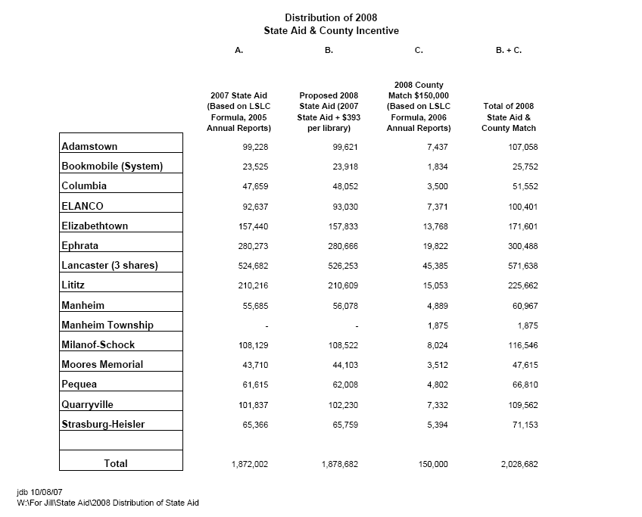
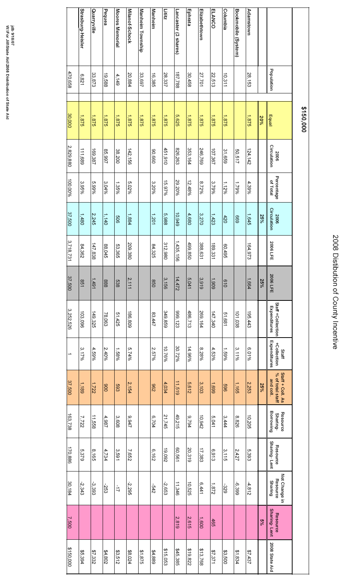
LYCOMING COUNTY LIBRARY SYSTEM

To: System Board Members
From: Janice Trapp, Executive Director
Re: Funding Formula for the Lycoming County Library System
In advance of what promises to be an interesting discussion in 2007 about how county funding is allocated to member libraries, I am sending you some information on funding formulas and a proposal for a new system to use locally. This proposal is based on a basic premise I hope we all share that is that the county does not provide tax support to the system to support libraries. It provides it so that county residents can access and utilize quality library services. As we discuss funding (never an easy discussion to have), it may make it easier to remember our responsibility is not to our local boards, our staff, or even our own communities. We are responsible to the taxpayer.
Our current long-range plan is “expiring” and will need to be revised next year. The document will probably be several pages, but I think the core goal is to have as many county residents as possible benefit from the resources and services of the public library system in their roles as individuals, parents, business people, students, and lifelong learners.
Our long-range plan is built around our library system’s mission statement that is currently:
The Lycoming County Library System is Lycoming County’s free Information Utility, Lifelong Learning Center and Popular Materials Collective.
Beginning as the Preschooler’s Door to Learning our libraries provide a friendly environment in which children, young adults and adults can find the materials and services they need to enhance their personal and working lives.
This is fine and prioritizes our services to preschool children.
But here is another mission statement from an organization that recently located in Lycoming County,
“To be the best loved provider of books, music, films, and other entertainment and informational products and services. To be the world leader in selection, service, innovation, ambiance, community involvement, and shareholder value. We recognize people to be the cornerstone of the experience we offer by building internal and external relationships, one person at a time”.
This second mission statement belongs to Border’s Bookstore. Just food for thought as we think about library services over the next five years.

Background
There are 33 library systems in Pennsylvania. Most counties in the state use the system structure rather than the independent library model. The system configuration is the infrastructure Commonwealth Libraries prefers. As an incentive for system development, it is easier to qualify for state aid in terms of local effort as a system. County tax dollars earn more in state dollar return than other municipal or school district dollars.
Existing Formula & Rationales
Currently there is no standardized state endorsed formula for systems to use to distribute state and local funds to member libraries. Each system determines its own distribution formula. There are many formulas in use across the state from the simple to the mind-numbingly complex.
State Aid Distribution
The formula currently in use in Lycoming County distributes state aid based upon the number of persons in the member library’s service area. State standards say that a library’s service area is comprised of those municipalities from which it derives 60% of its usage. The basic categories of state aid we receive every year are divided by the number of county residents to determine the multiplier. County coordination aid goes to county libraries. This money is used to offset the costs of county services or services JVBL would not offer if it did not assume responsibility for the entire county. This category of aid cannot be distributed to member libraries. Equal grants are equal. I do not recommend changing the way we distribute state aid. If a member library feels it is actually serving more municipalities than it is currently receiving state aid for, it has the option to document that and request that the system board adjust its service area to include additional municipalities. The best way to document this would be to record the municipal residence of every user for an adequate sample period.
County Aid Distribution
County funds are distributed based on a formula adopted when the system was working to consolidate local funding at the county level. Some libraries were receiving donations from a number of smaller municipal units. To encourage their willingness to join the system we promised to use county money to match the level of local effort achieved by every library at the time. Our pitch to the county was simple. If they provided the local funding that “earns” state funding instead of having our libraries run around trying to convince many smaller municipalities that they should provide funding for libraries, it would streamline our operations and also equalize per capita funding. Under the prior funding mechanisms some municipalities provided five cents per capita. Others provided $5., and the county also provided funding so the “double taxation” complaint was often heard. Every library saw funding improvements because the balance of the county appropriations was distributed on a service area per capita basis. In subsequent years libraries received percentage increases on county funding that paralleled the overall percentage increase in the annual appropriation. The only item funded before from the distribution is the maintenance and enhancements costs to the shared automated system.

Migration to New formula
I have a new formula to propose. It is not based on test runs to see who will benefit and who will lose. To be successful a new formula can only be based on a consensus that the formula itself is fair and is responsible to the shareholder (taxpayer). This proposal is based on the theory that the county invests dollars in the library system as a delivery mechanism for a service. Here are the ways I think we can determine how much of the service each member library should be paid for providing:
40% based on “sales” as measured by circulation using the Access PA model of reimbursing for loans outside your assigned service area but still within Lycoming County at a higher rate. This will compensate libraries for use of their materials by county residents from the service area of another library in the county. Most libraries receive significant usage from cardholders at other libraries. The system works!
15% based on market share as measured by the percentage of total cardholders each library “owns”. Cards must have been used within the past 12 months to be considered valid.
5% based on growth in market share as determined by the number of new cards issued and used by member libraries during the past 12 months. This will encourage libraries to be more proactive in marketing library cards.
10% based on summer reading registration shares (or all children’s programs) = this is incentive to service that segment of the market, the “Preschooler’s Door to Learning”, prioritized in our long-range plan.
10% based on the quality of inventory as measured by collection turnover rate of the last 12 months. Turnover rate is how many times, on average, your circulating materials are checked out each year. A low turnover rate suggests a collection full of dead wood. A high turnover rate suggests a collection developed to appeal to the customer. This will stop member libraries from adding donated items of little interest to their collections and “clogging” the database and over-utilize the services of technical services with little or no return in circulation.
20% website hits/reference questions. Circulation of materials, while still the basic statistic we use, is becoming less a benchmark for measuring usage as more people become virtual customers or consume information services without checking anything out.
The formula would be dynamic changing based on the prior year’s performance. It would stimulate a proactive approach to generating more usage, more customers, and better collections. In terms of convenient access to library service, I’d also suggest some bonus funds for libraries willing to be open on Sundays. I think this new approach to a new formula would be fair to all, encourage proactive services, and best serve the needs of the taxpayer.
The Formula Four-Way Test -
Is it customer centered? Is it fair to all concerned? Will it build a better library product responsive to changing needs? Will it be beneficial to all county residents?
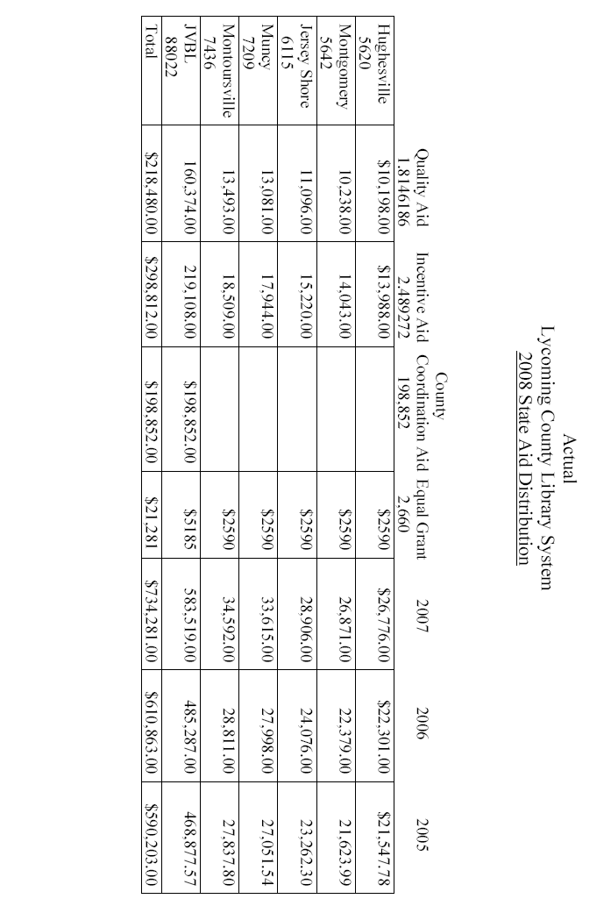
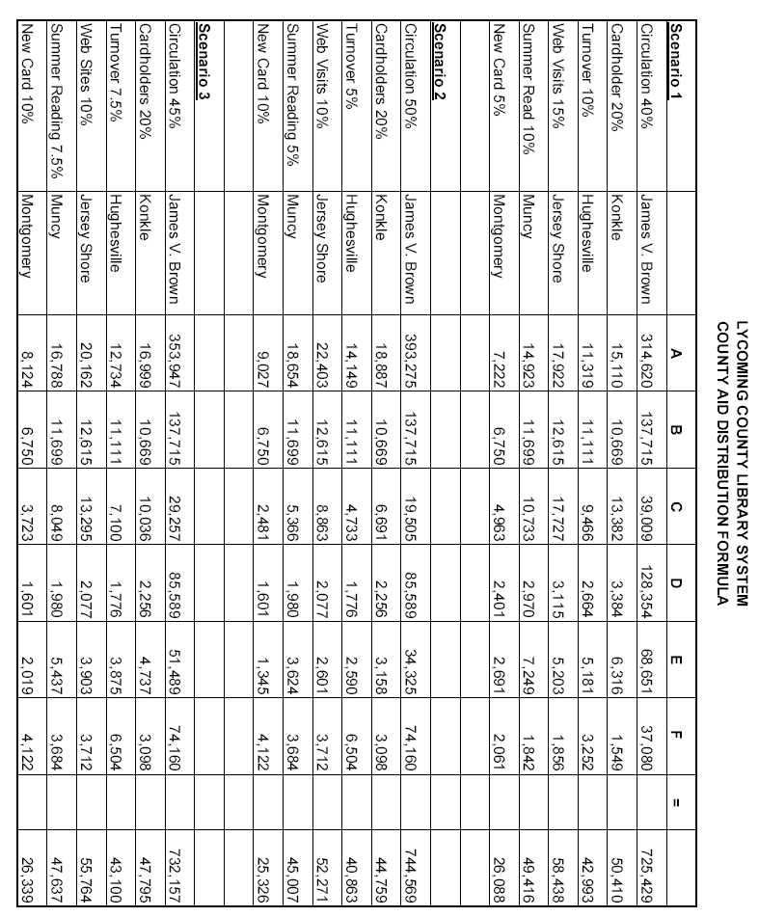
LUZERNE COUNTY LIBRARY SYSTEM

County Funding

The system board (made up of one librarian and board representative from each of the ten system members) determines how much of the $1.3 million appropriation will be distributed, based upon the Administrator’s budget for expenses, automation and reserve fund requirements. The distribution formula for county funds includes the following:

Basic Grant = 10% of total appropriation, taken off the top, up to a maximum $25,000. The LCLS distribution formula changes when we hit this maximum, so that Part 2 increases from 50% of the total distribution to 60% of the difference between the total appropriation and the $25,000 maximum. The $25,000 is subtracted from the amount available for distribution. Each library receives $2500 maximum in this category. We have been at the maximum for this category for about three years.

Population = 50% of total appropriation (60% when the Basic Grant category is at its maximum)

Local Effort = 20% of total appropriation

Circulation = 10% of total appropriation

Hours Open = 10% of total appropriation

The population, local effort, circulation and hours open are prorated based on each member’s numbers. We use the information from the most recently completed Annual Report when figuring this formula. So when the 2008 distribution was prepared, we used the 2006 annual report information.

State Funding

For state aid distribution, we use whatever method Commonwealth Libraries is using in a given year, so that libraries are paid as though they were independent libraries and not system members. This was one of the conditions upon which the Luzerne County Library System was founded. Its corollary is that each member agreed to meet standards for independent libraries rather than the slightly lower system standards.
POTTER-TIOGA LIBRARY SYSTEM

The objective of this formula is to encourage the libraries to spend more and provide the best library service possible and at the same time to help the smaller libraries with their funding. A large percentage of the total funds is split according to the libraries' percentage of the total local effort of the county, thereby acting as an incentive for the libraries to spend more on service. By distributing a small percentage of the funds equally, the formula helps to provide some equity for the smaller libraries.

FUNDING FORMULA

SYSTEM BUDGET
The System budget is funded totally by a portion of the State and County Aid received by both counties. Based on population, 1/3 is funded by Potter County and 2/3 by Tioga County. After the System budget is approved by the System Board, a percentage is calculated for each county (the cost of the System budget compared to their total state and county aid). This percentage comes off the top of each check received. Then, the remainder is divided between the libraries by the funding formula.
The percentage for the System covers the salaries of two full-time employees, the costs involved with providing library service to the unserved areas of the counties and to supplement the local library collections. There are 15 deposit libraries provided with quarterly rotating collections and rotating collections of large-type and books on tape and CD are provided to the local libraries. Also, continuing education funds are available to each librarian.
The System does no fund-raising because it would impinge on the fund-raising efforts of the local libraries.

DISTRUBITION FORMULA

Potter County: 25% is divided equally
75% is divided by the local effort percentage

Tioga County: 30% is divided equally
70% is divided by the local effort percentage

The local effort percentage is each library’s local effort (total expenditures from the last annual report minus State Aid, Access PA money and the cost of raising money) divided by the total local effort of all the libraries in the county.

COUNTY AID
Every year we meet with the Commissioners and ask that our appropriation be increased. Tioga County pays in quarterly installments; Potter County makes one payment, usually in June. The percentage to fund the System’s budget is subtracted from the total received and the remainder is split by the distribution formula.

STATE AID
The total amount of State Aid is determined by the State’s budget every year. There are several categories of State Aid including: Quality Libraries Aid (per capita), Incentive for Excellence Aid (based on expenditures per capita), County Coordination Aid, Equalization Aid and Equal Distribution Grants. These are combined into one amount for each county and payments are made in January (90%) and March (10%). After the System’s percentage is deducted the remainder is distributed to the local libraries by the formula, except for the County Coordination Aid, Equalization, and the Equal Distribution Grants.
County Coordination Aid has to be used to provide a county-wide library service. Every year, the system must submit a plan and budget for the use of this money, signed by all the library directors for approval by the State Library. This money can not be distributed to the libraries.
The Equalization Aid is based on low personal income per capita, low market value of real estate or high unemployment. This amount is divided equally between the libraries.
All of our libraries qualify for the Equal Distribution Grant and are obliged to spend the grant plus an equal amount of their own money on library materials. This amount is split equally between the libraries.
When State Aid is received, County Coordination Aid is subtracted, then the percentage needed to support the System, then the Equal Distribution grant and Equalization Aid are divided equally. The remainder is then split according to the distribution formula.

SCHUYKILL COUNTY LIBRARY SYSTEM

State Aid Distribution

State aid is distributed to system members based on their service areas. Independent (non-system) members apply for their state aid directly.

County Funds Distribution

25% divided equally among 5 independent libraries.
25% to system headquarters to provide service to unserved areas, including the 7 system members.
50% divided based on local expenditures, among the 5 independent libraries.

SOMERSET COUNTY FEDERATED LIBRARY SYSTEM

I have a governing board of 7 members. The Somerset County Federated Library System money is distributed according to service area. The income is from Somerset County ($185,000 this year), the State, municipalities, schools & townships (perhaps $20,000), Fund Drives ($40,000), In-Kind (Allegany College, Experience Works, Tableland - not distributed but helps with local effort), Desk contributions & donations, etc.

The System Headquarters has an office in the Somerset County Library, Headquarters for System. The System operates the bookmobile. There are 2 people on the bookmobile. The System also employs the Administrator (me), a second MLS, and a B.S. staff person who operates a van service between the libraries once a week - total of 5.

The county coordination plan usually addresses the bookmobile, competition books, Internet, Education, and the van service. The System completes E-rate forms for all libraries.

The System encompasses the following libraries: Meyersdale Public, Windber Public, Somerset County Library & branch Somerset County Conemaugh Branch, and the bookmobile and System.

WASHINGTON COUNTY LIBRARY SYSTEM

Funding formulas for Washington County Libraries:

County Aid:

Taken “off the top”: $3,000 Rotating DVD Collection
1,000 Audit
1,500 Insurance

Total distributed to libraries in 2007: $160,135.

Formula: ½ distributed based on % of local effort
¼ Equal Distribution
¼ Per Capita Distribution.

State Aid:

Base Aid = Quality Libraries Aid + Incentive for Excellence Aid

All libraries are treated as if they are independent local libraries and receive what they would receive if they met the $5.00/capita standard.
Quality Libraries Aid: amount x population
Incentive for Excellence Aid is calculated for libraries over $5.00/capital

Incentive A: Libraries whose local effort is over $5.00 – 7.50 rewarded at .80 cents
.80 x amt. over $5 x population

Incentive B: Libraries whose local effort is over $7.50 - $15.00
.06522523 x amt. over $7.50 x population

Incentive Aid: ¼ total aid and is based on % of local effort.

Per Capita Aid: 3/8 of total aid. 3/8 of total aid divided by county’s population for multiplier (.419589738)
Library population x multiplier

Equal Distribution Aid:
3/8 of total aid divided by number of libraries (14) and distributed evenly.
WAYNE LIBRARY AUTHORITY

For the Wayne Library Authority, county money and state money are distributed by different formulas:

Formula to distribute county allocation is a bit complicated. (This was hammered out over two-year period as we went toward a referendum. This was the one version everyone could agree on.)

50% of annual allocation is divided by flat percentage to assure everyone a base amount. Seven member libraries get 10% of the 50% each. The remaining 30% of 50% is distributed to the system headquarters library.
25% of annual allocation is distributed to libraries according to the population in their service area as a percentage of the county population.
25% of annual allocation is distributed to libraries according to their combined circulation/collection as a percentage of the county total for the prior year.

Additionally, the year of drastic state aid cut the commissioners provided $10,000 to the system. Since then, they've continued the $10,000 which is the only local funding for the system. That now gets deducted off of the allocation before we calculate the formula.

Formula to distribute state aid:

Quality Aid and Incentive Aid are distributed to libraries on per capita basis by population.
Equal Grant is distributed as Equal Grant.
County Coordination Aid is kept by the system to fund our core system needs:
- circulation software license, filtering license, web hosting, and related networking
- delivery service inside the county (contract driver, not an employee)
- annual audits/financial reviews and a shared online donor management system
- Internet costs for member libraries (and system applies for E-rate for Internet)
- collection supplies that are countywide -- patron cards, barcodes, registration forms
- some cataloging help and tech support, but pretty limited
- dues to Access PA for members, institutional dues to PaLA
- a countywide training day for staff/volunteers

WESTMORELAND COUNTY FEDERATED LIBRARY SYSTEM

This is how we distribute the county funding that we receive:

The distribution was based on our 2003 amount which was $150,000.
The 4 parts to the formula are:
% of total county local funding effort
% of total county staffing in FTEs
% of total county collection
% of total county population

It used numbers from the annual reports, added up all the totals, calculated the individual percentages, averaged out the 4 percentages and gave each library that percentage of the total county funds. The System Headquarters office also takes a part of the total county funds, but I'm not sure how that was calculated in the past.

When we became the System headquarters in 10/05, our first budget year was 2006. We gave each member the same amount they received in 2005 and kept the same amount for System operations. In 2007 we received a slight increase ($9,000) which we retained for System Headquarters. In 2008 we received a 23% increase in county funding, we gave each member library a 3% increase and kept the rest to offset the costs for the ILS. This was approved at the January 2008 System board meeting.

Our distribution formula for state aid follows exactly the same distribution each member library would have received if it were an independent library, not a member of the system.
YORK COUNTY LIBRARY SYSTEM

Funding Formula

Adopted by the York County Library System Board of Directors July 1987
Updated to be consistent with Library Code language October 2001 (edits appear in italics)

STATE AID
All of the Quality and Incentive Aid for Excellence categories is divided between the member libraries and the branches:

- 25% is divided on an equal share basis, i.e., if there are 13 libraries in the System, each gets 1/13 of 25% of the Quality and Incentive Aid.

- 75% is divided by local effort, i.e., if one library had 10% of the total local effort, it would get 10% of 75% of the Quality and Incentive Aid. Local effort is defined as expenditures from sources such as: donations; fines; municipal funds; copier income; school board allocations; gift or memorial books; gifts especially purchased for library (such as Jaycees buying equipment), subsidized employment (if documented); in-kind contributions (such as rent, cleaning service, etc., if documented).

By way of general definition, local effort includes funds expended to improve library service to the public. Capital expenditures of up to $20,000 can be included in the local effort figure. Some examples of expenditures in this category would be addition of floor space, renovation, addition of parking space, purchase of new furniture or equipment, adding air conditioning, etc.

Volunteer time is not counted toward local effort.

We use the local effort figures of the previous calendar year.

COUNTY AID

Not less than 30% of the county appropriation for the System’s general fund (this excludes appropriations for capital expenses) is divided among member and branch libraries by the same formula as the Quality and Incentive Aid for Excellence categories of State Aid.

Libraries coming into the System are eligible for only the “equal share” category of State and County Aid until they have been in operation one full calendar year.

The System retains the State and County Aid for branches for its expenses related to that branch.

